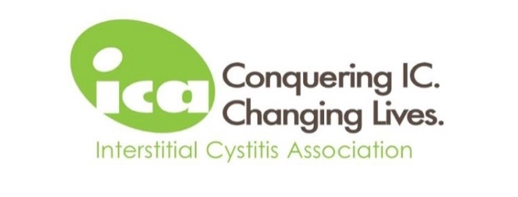
ICA Medical Advisory Council (MAC) Application Form

Name:

Address:

Email Address:

Phone Number (please indicate work, home, or cell):

Education/Training/Certificates:

Please also submit your most up-to-date resume/CV with a cover letter that details:

- Why you are interested in and willing to assume the responsibilities of a MAC member.
- Your subject matter expertise and the type(s) of educational content you might be able to provide the ICA.
- How you stay current in the peer-reviewed scientific literature on IC/BPS.
- How you will have sufficient time to devote to the performance of the duties of a MAC member.
- In your personal and professional dealings, how you demonstrate integrity, high ethical standards, and respect of privacy and confidentiality.
- Your experience volunteering with or serving nonprofit organizations.

Signature: Date:
(typed name is fine)

Email this completed application form, your resume/CV, and a cover letter to lee.lowery@ichelp.org.

Please ensure all documents are attached as Microsoft Word documents or PDFs.

